Business News & Trends –
January 2023 Newsletter

Hey Insider Family!
This is our Winter issue and it’s the start of a new year. Do you make resolutions? I no longer do that, but I am a goal setter which I find it more effective for me. What are your career goals for this brand-new year? One of my recent goals was to get some great guests for Season 3 of the Insider’s Career Club Podcast. This goal has been accomplished and you’ll reap the by-product of that success.
There are some great guests on tap: Anna Runyon the Founder of CLASS and CEO of Classy Career Girl International; and Brenden Kumaraswamy, Founder of MasterTalk, who coaches executives to become the top 1% communicators. I’ll kick things off with a podcast on the 9 Traits of Exceptional Leaders. The podcasts are dynamite so stay tuned.
This Winter issue has a few predictions for 2023, newsy morsels, inspirational quotes, and Career Podcast and Coaching information to get your career rolling in the right direction for 2023.
Inspiration is up next!

Best!
Sindy, your Career Insider

Inspiration:
“If you set your goals ridiculously high and it's a failure, you will fail above everyone else's success.” James Cameron
“You can’t go back and change the beginning, but you can start where you are and change the ending.” C.S. Lewis
““Success is not the absence of failure; it’s the persistence through failure.” Averstu.com

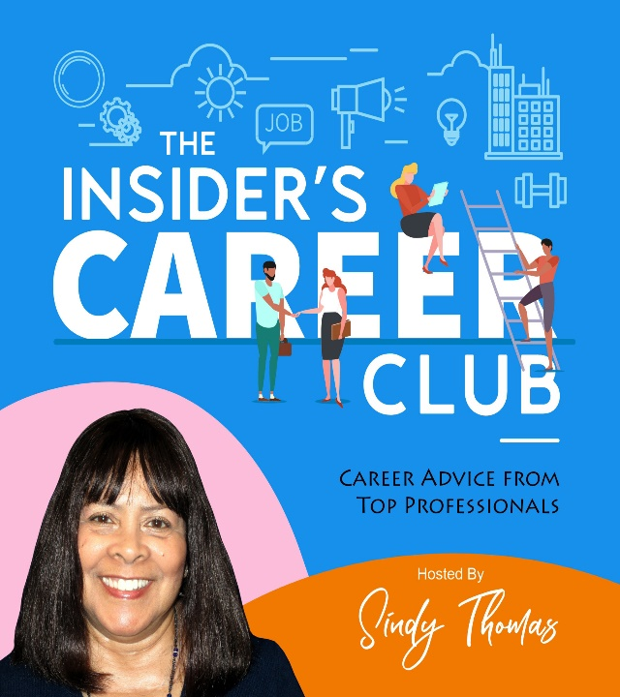

Insider’s Career Club Podcasts – Coming Up!
Insider’s Career Club Podcasts go LIVE on 1/4/23 & 1/18/23 Be sure to join us!

ICC – 3, Episode 1, “You Want To Lead? Do This, with Host, Sindy Thomas
Sharing the 9 Traits of Exceptional Leaders and aspiring Leaders.
Listen: https://www.buzzsprout.com/1448059/11811908 or Apple, Google, Amazon Music, Spotify, IHeartRadio & more @insiderscareerclub.com

ICC 3-2, Episode #2, Anna Runyan, CEO Classy Career Girl International
This podcast is for women who want to start their own business. Anna talks about her journey and shares resources she offers. Listen: https://www.buzzsprout.com/1448059/11346864 or on Apple, Google, Amazon Music, Spotify, IHeartRadio & more.

BUSINESS NEWS & TRENDS –
January 2023

BUSINESS NEWS
Get comfortable, grab a blanket, and have a cuppa. Here are some interesting news tidbits for you.

2023 Predictions
According to Raghav Singh from TLNT has made these predictions:
- “Despite all the news about layoffs in the tech industry, it’s my view that there will be little impact on the wider labor market.”
I agree with this outlook due to the scarcity of qualified workers in the US has been adversely impacted due to a stall in employers being able to bring and sponsor new H1B skilled workers into the country as well as the immergence of an increase in a dependance on technology. Workers are forced to keep their skills and knowledge up due to a labor market that continues to morph like a transformer. These changes combined with the low employment rate, I think anyone who is skilled at the more entry levels and at the higher levels requiring more specialized experience and skills will be able to find work.
- Wage pressures will reduce a little. The Bureau of Labor Statistics reports that compensation costs increased 5% over the last 12 months.
The Federal Reserve’s efforts to tamp down wage inflation will have some effect by reducing business activity, but short of forcing a deep recession, it’s unlikely wage pressures will reduce much.
Around 40% of employers reported raising compensation in November, and 28% plan to raise compensation in the next three months to retain workers and fill open positions.
My thoughts--though wage pressures may slow overall, this competitive marketplace is forcing employers to work hard to keep the talent they’ve fought so hard to find. The pace of hiring may slow a little, but employers are still seeking ways to stay competitive and are finding new perks and benefits to give employees’, so they stay. Compensation, upskilling, flexible work schedules, remote work and focusing on keeping a balance at work are employee priorities and are cards on the employer table. They may want to look at opportunities for internal mobility for employees because it has proven to increase retention.
The components of offer packages and benefits may also change and shift for candidates. However, salaries will continue to rise so companies remain viable in the marketplace and due to fluctuating inflation. However, even though hiring will continue it will not be at the wild pace of recent years. The bargaining power of workers is slowly shifting back to employers because of the impending threat of a recession.

The FTC Noncompete Crack Down

Per HR DIVE – “The Federal Trade Commission (FTC) has started to crackdown on noncompete agreements, the agency announced Jan. 4 — in the same week it proposed a rule that would ban a noncompete entirely. The reasoning is that noncompete(s) “agreements harm competition, suppress labor mobility and reduce wages even for those not bound by a noncompete agreement.”
The FTC filed complaints against three companies and two individuals, alleging that each “imposed noncompete restrictions on workers in positions ranging from low-wage security guards to manufacturing workers to engineers that barred them from seeking or accepting work with another employer or operating a competing business after they left the companies.”
The complaints were against Prudential Security, Inc., O-I Glass, Inc. and Ardaugh Group, SA. Prudential’s non-compete focused on employers accepting job within 100 miles and higher wages. The two glass companies allegedly in non-competes restricted employees from accepting jobs in the glass industry anywhere in the US for up to 2 years after leaving the respective companies. The FTC is fighting against this ridiculous noncompete which has hindered former employees from earning a living.
Just imagine leaving a job you didn’t like and were underpaid in it. After leaving you go thru the difficult interviewing and hiring process and get another job offer with another company. Your old employer finds out and sues you for taking another job. Imagine that? Well, that’s what happened to many former employees of glass companies. The glass companies were going after former employees and asking that they been fined up to $100K. Glad the FTC is looking into these unfair labor practices.

GOOD NEWS

Jump for joy! I cannot watch stocks every day. I’d be a nervous wreck. Per Bloomberg, US stocks had their best day in over a month because traders speculated that the slowdown in wage growth will keep the Fed from making more rate hikes. Fingers-crossed. May it continue to rise in our favor. American’s 401K’s and retirement savings have taken enough hits.
The S&P 500 increased more than 2% and Nasdaq 100 rose 0.9% this week.

THE ECONOMY & JOBS

Wall Street Job Cuts
With the possible recession looming in the proverbial wings and the loss of jobs in the Tech Sector. Wall Street is reacting by making job cuts and hiring freezes. Goldman Sachs Group, Morgan Stanley, Wells Fargo, Credit Suisse Group, AG, and Barclays Plc have already fired staff or are planning on doing so.
Real estate companies are also announcing layoffs. Redfin announced in November 2022 a layoff of 27% of its’ workforce.
Trends – Women and Work

The following is a sad comment on the state of women in the US workplace. For all the progress women thought we made, it seems true progress has been slow, and we may in future be losing ground.
As women work to become managers, leaders, and executives it looks very much like a recruitment funnel. At the start of the funnel, you start with multiple women candidates but as you advance candidates fall out of the running until you get to the final one. In the report findings below depending on their direct supervisor/manager women may not get a chance to advance into manager positions. It all rests on their managers commitment to DEI. Take a look at the report findings from a recent report from McKinsey & Company.

McKinsey & Company report -Women In The Workplace Report 2022 has some disturbing facts to share about drastic changes and working women:
Women, especially women of color are drastically underrepresented in Corporate America.
- 1 in 4 C-Suite leaders is a woman, of that 1 in 20 is a woman of color.
- There is a “broken rung” at the first step up to manager which is holding women back.
- For every 100 men promoted from entry-level to manager, only 87 women are promoted, and only 82 women of color are promoted.
- The results are cumulative, resulting in men outnumbering women and it prevents women from gaining ground.
- Women leaders are currently leaving at the highest rates in years, giving companies a pipeline problem. Which may mean companies may also loose the next generations of women too.
- Young women are more ambitious and younger women place a higher premium on working in an equitable, supportive, and inclusive workplace.

Tech News

Salesforce announced this week it will cut 10% of its’ workforce across the board.
Marc Benioff, CEO, blamed “over-hiring” during the pandemic for the job losses.
Salesforce will also close some offices. Benioff has taken responsibility for over-hiring. Salesforce has also announced it will reduce its real-estate holding on top of layoffs.
Andy Jassy, CEO, Amazon sent a message to employees that it will eliminate 18,000 positions. They will offer the option of voluntary severance to those in impacted people, experience, and technology groups. The company has also enforced a corporate hiring freeze and revoked job offers.

December Unemployment Rate
The BLS.gov reports payroll employment increased by 223,000 in December. The unemployment rate edged down to 3.5 percent from 3.7 in November. These notable gains occurred in leisure & hospitality, health care, construction, and social assistance industries.

The Insider’s Career Club - Career Services
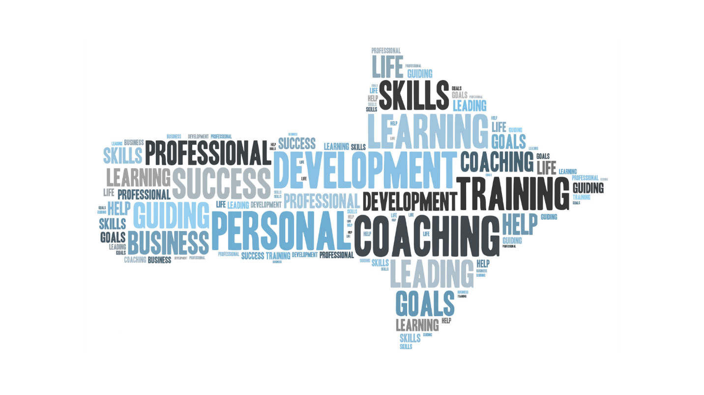

Career Coaching:
Looking to change jobs. Got a big interview coming up?
Increase your chances to progress to the next interview. A Mock Interview Coaching Session helps to hone your interviewing skills so you can shine. Sign-up today!
Considering a career pivot? In a Career Exploration Session, I’ll work with you to guide you on your path to making the career change that’s right for you.
Let’s explore the career direction best for you. Book a free 20-minute Discovery call now!
Services:
- Resume Review
- Mock Interviewing
- Career Coaching

Get more information on the Career Services page at : www.insiderscareerclub.com

